

A Comparative Analysis of Hydraulic Stability Methods for Rock Protection of Subsea Cables in Nearshore Environments





Willem Pol
Version 1.0
30-6-2026
Content
1. Introduction 3
2. The Nearshore Environment 4
2.1 Definition and area of interest 4
2.2 Complexity of Nearshore Environment 5
2.3 Bed Morphology and Composition 8
3. Hydrodynamic Forcing 10
3.1 Currents 10
3.1.1 Introduction 10
3.1.2 Tidal Currents 10
3.1.3 Astronomical tide 11
3.1.4 Tide types 12
3.1.5 Wind-driven Currents 12
3.1.6 Density-driven Currents 13
3.1.7 Wave-induces currents 13
3.1.8 Current characterization for protection design 14
3.2 Waves 15
3.2.1 Source and description of wave data 15
3.2.2 Statistical description of wave climate 15
3.2.3 Wave periods and characteristic time scale 16
3.2.4 Linear wave theory 17
3.2.5 Wave propagation toward the site of interest 18
3.2.6 Relevance for stability 20
3.3 Wave-Current interaction 21
4. Near-bed Flow Conditions 22
5. Stability Parameters & Criteria 23
5.1 The Shields Parameter — Uniform Flow 23
5.2 Turbulence-based Parameters 23
5.3 Combined Wave-Current Conditions 23
5.4 Decision Framework 23
6. Rock Stability Assessment Methods 24
6.1 Hudson Formula 24
6.2 Van der Meer (1988/1998) 24
6.3 Van Rijn (2019) 24
6.4 Van Gent & Van der Werf (2014) 24
6.5 Herrera & Medina (2015) 24
6.6 Deltares HaSPro Handbook (2023) 24
6.7 Comparative Summary 25
7. Scour 26
7.1 The Scour Process 26
7.2 Scour Around Subsea Cables 26
7.3 The Scour Process 26
7.4 The Scour Process 26
8. Design Framework & Computational Approach 27
8.1 Input Parameter Space 27
8.2 Core Design Formulae 27
8.3 Failure Criteria & Damage Levels 27
8.4 Validity Ranges & Applicability Warnings 27
8.5 Sensitivity Analysis Framework 27
9. Knowledge Gaps & Research Questions 29

Introduction
- The rapid growth of the offshore wind sector
- the increasing deployment of subsea cables as critical energy infrastructure
- the intensification of hydrodynamic loading due to climate change.
- Why are existing design methods are not always suitable for nearshore cable protection?
- the gap this thesis addresses.
- research objective and scope of the study.

Schiereck & Verhagen (2019) — Ch. 1 (Introduction: why and when, protection against what, failure and design)
Deltares Handbook (2023) — Ch. 1 (Background, considered foundation types) & Ch. 3 (Scour mitigation strategies)

The Nearshore Environment

Definition and area of interest
The coastal region is not a single uniform zone but different areas with different physically difficulties, each characterized by different hydrodynamic conditions and levels of seabed interaction. For the purposes of this study, it is essential to distinguish between three zones: the deepwater/offshore zone, the nearshore zone/approaching zone, and the surf zone (Figure x).
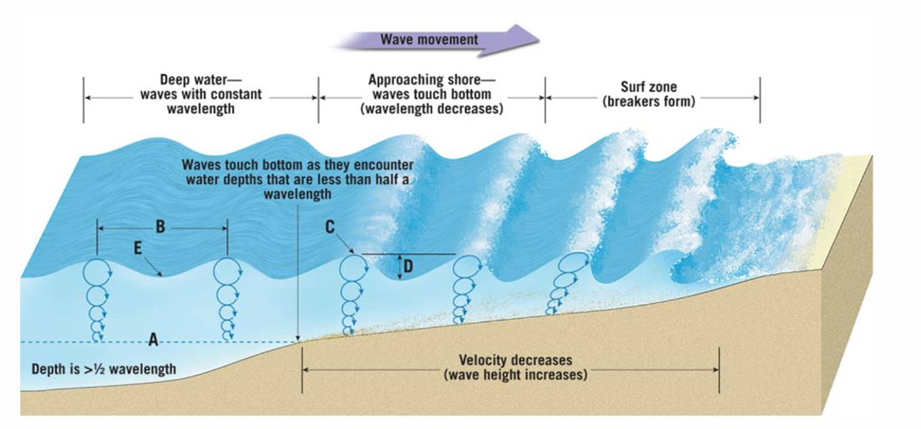
The offshore zone is characterized by water depths sufficiently large that surface waves do not interact with the seabed. In this region, waves propagate largely undisturbed, and the flow conditions above the bed are governed primarily by tidal and large-scale oceanic flows. Wave-induced orbital velocities become negligible at the seabed when the water depth exceeds approximately half the wavelength ($h > L/2$). Offshore conditions are therefore relatively well understood and predictable, and the design of cable protections in this zone is more straightforward.

The nearshore zone begins where waves start to feel the seabed, where ($h< L/2$) and extends landward to the point where waves begin to break consistently. This is sometimes referred to as the shoaling zone. In this zone, the interaction between wave orbital motion and the seabed becomes significant: wave celerity decreases, wavelength shortens, and wave height first increases through shoaling before eventually being limited by depth-induced breaking. This zone is the primary focus of this study, as it is precisely here that many nearshore cable routes are laid, and where the complexity of hydrodynamic loading is greatest.

The surf zone extends from the breaker line to the shoreline. In this zone, waves have broken and energy dissipation through turbulence dominates. Longshore currents, undertow, and swash processes are characteristic of this zone. While surf zone dynamics are of interest to coastal engineers, subsea cable routes generally avoid the surf zone due to the extreme and highly variable loading conditions. This study therefore focuses on the nearshore zone, with some attention to the transition region near the breaker line where also wave breaking can occur.

Complexity of Nearshore Environment
What makes the nearshore zone fundamentally more complex than the offshore environment is the convergence of multiple physical processes acting simultaneously at or near the seabed. The following processes are of direct relevance to the hydraulic stability of rock protection systems.
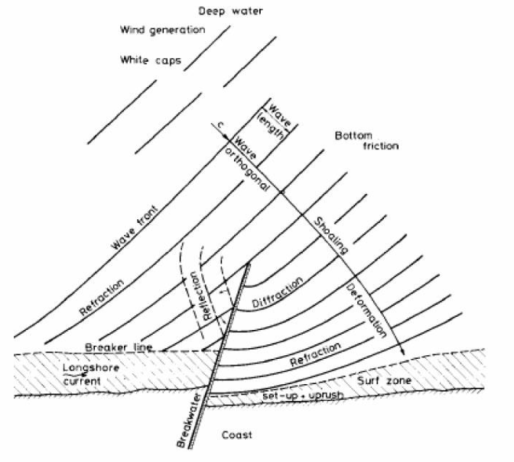

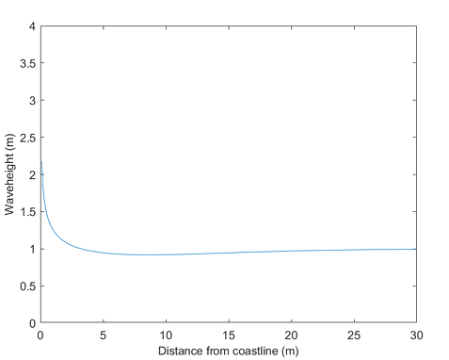
Shallow water effects. As water depth decreases, the behaviour of waves departs progressively from deep-water linear wave theory. The dispersion relation becomes depth-dependent, wave orbital velocities at the seabed increase significantly, and the wave profile becomes asymmetric, with steeper fronts and flatter troughs. This asymmetry leads to net sediment transport in the direction of wave propagation, which is an important consideration for the long-term stability of any bed protection. Schiereck and Verhagen (2019) describe how waves travelling from a depth of 20 m towards the shore undergo a complex sequence of shoaling, bottom friction, and eventually breaking, with the relative importance of each process depending strongly on the bed slope.

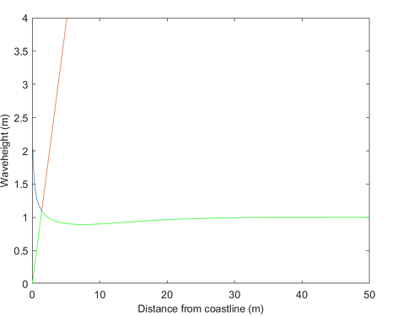
Wave breaking. Breaking occurs when a wave can no longer sustain its form, either because it becomes too steep in deep water or the water depth becomes too shallow. The breaking criterion given by Miche provides a theoretical upper limit for wave height as a function of local depth and wavelength (Schiereck & Verhagen, 2019, Eq. 7.8). In practice, for shallow foreshores, a useful approximation is $\frac{Hb}{hb}$ ≈ 0.88, indicating that the significant wave height is strongly depth-limited in the nearshore zone. Breaking waves represent a different loading category compared to non-breaking waves. The impact forces generated during breaking are highly turbulent and difficult to predict using standard wave theories. For rock protection design, this means that standard stability formulae derived for non-breaking or mildly breaking conditions may significantly underestimate the actual loading (Herrera & Medina, 2015).

Tidal influence. Tidal fluctuations changes the water depth in the nearshore zone, causing the breaker line and the zone is moving over time, back and forth across the seabed over the tidal cycle. This has two important implications for cable protection design. First, a protection layer that is adequately stable at high water may be exposed to breaking wave impact at low water, when the same location is in significantly shallower water. Second, tidal currents themselves contribute to the bed-shear stress on the protection layer, and their direction and magnitude vary over the tidal cycle, sometimes in combination with wave action.

Wave-current interaction. In most nearshore environments, waves and currents co-exist. Their interaction is non-linear, the combined bed-shear stress produced by simultaneous waves and current is greater than the simple sum of each contribution separately. This is because the wave boundary layer significantly enhances the apparent bed roughness experienced by the current, and vice versa. Schiereck and Verhagen (2019, Section 7.2.2) show that the resulting shear stress under combined wave-current conditions depends critically on the angle between wave and current direction, being maximum when waves and current are aligned (φ = 90°).
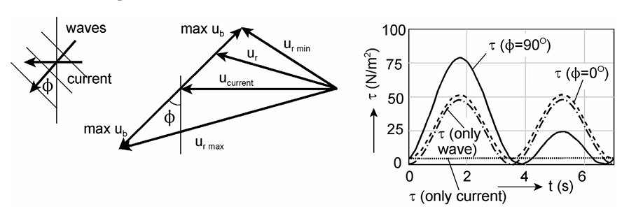

Sediment dynamics. Unlike the offshore zone where the seabed may be relatively stable, nearshore beds are often composed of mobile sediments, fine to medium sands, that are in a state of quasi-continuous transport under the combined action of waves and currents. This has direct consequences for rock protection: sediment can be winnowed (interface instability or piping) out from beneath or between the protection stones. The protection layer can sink into a softer underlying layer, and erosion around the edges of a protection berm can weaken its stability. The Deltares HaSPro Handbook (2023) states that, besides external stability, interface stability and flexibility are two of the three main requirements for offshore rock protections.

- Schiereck & Verhagen (2019)
Ch. 7.3 (Breaking waves, waves on a foreshore)
Ch. 2 (Flow loads, introduction)

- Deltares Handbook (2023)
Ch. 2 (General definitions, general description of the scour process)

Bed Morphology and Composition
Subsea cable routes in nearshore environments have a lot of variety of seabed types, each presenting distinct challenges for rock protection design.

Sandy beds are the most common substrate in nearshore zones along low-lying coasts. Fine to medium sands (D50 in the range of 0.1–0.5 mm) are highly mobile under wave and current action, making them being easily influenced to scour around and beneath cable protection structures. Sandy beds also present challenges for filter design, as the fine sediment can be transported through the voids of the protection layer if the grading is not properly designed (Schiereck & Verhagen, 2019, Ch. 6).

Mixed sand-gravel and gravel beds occur in higher-energy and bit steeper nearshore environments, such as exposed Atlantic coasts or tidal inlets. These substrates are generally more stable than pure sand beds, but their coarser and irregular texture complicates the interface between the natural bed and the protection layer.

Rocky and consolidated beds are commonly found along steep coastlines, especially in fjord areas and around rocky headlands. These seabeds are generally stable and do not have a risk of winnowing. However, their uneven surface can make it difficult for the protection berm to fully connect with the seabed, which may create unsupported gaps beneath the berm. Herrera and Medina (2015) explain that steep rocky coastlines (with slopes of 1/10 or steeper) behave very differently from gentle sandy slopes. As a result, existing design formulas developed for sandy coastlines are not suitable for these conditions.

Morphological features that are important for cable route planning include sand bars, tidal channels, and cross-shore seabed profiles with alternating shallow and deeper areas. These features create variations in wave breaking, current strength, and bed-shear stress along the route. As a result, using one representative design cross-section may not be sufficient, and a more detailed spatial assessment along the cable route may be needed.

The nearshore environment is physically complex because waves, tidal currents, wave breaking, wave-current interaction, and moving sediments all occur at the same time. These processes interact with each other and can create loads that are much larger than those caused by a single process alone.

The seabed in the nearshore zone can vary from mobile sandy beds to steep rocky areas, and each type creates different challenges for the design and long-term stability of rock protection systems. A good understanding of these conditions is necessary to determine whether existing stability methods, mainly developed for offshore or sheltered coastal environments, can also be applied to nearshore cable protection.

The following chapters build on this background step by step: Chapter 3 discusses hydrodynamic forcing, Chapter 4 focuses on near-bed flow conditions, Chapter 5 introduces stability parameters, and Chapter 6 evaluates the available assessment methods.

- Schiereck & Verhagen (2019)
Section 7.3 (Breaking waves)
Section 7.3.2 (Waves on a foreshore)
Section 7.2.2 (Shear stress under waves)
Section 2.2 (Turbulence)
Ch. 6 (Filters)

- Herrera & Medina (2015)
Introduction and Section 1 (steep sea bottoms, shallow water)

- Deltares HaSPro Handbook (2023)
Ch. 2 (General definitions)
Ch. 4.2 (Performance requirements: external, interface, flexibility)

Hydrodynamic Forcing

Currents

Introduction
Currents in the nearshore zone are generated by a limited number of physical processes that influence the stability of rock protection along subsea cable routes. In this thesis, the nearshore is defined as the area seaward of the wave-breaking zone, where tidal flow and non-breaking wave motion are the main hydrodynamic processes of interest. These currents are important because they create bed shear stress, transport sediment, and can contribute to scour at the edge of the protection layer. For this reason, understanding the current types present and their typical magnitudes is essential for any stability assessment.

In hydraulic design, flow above a protection layer is often described using the depth-averaged velocity. This is a practical parameter because it is easy to use in calculations and design formulae. However, as Schiereck and Verhagen emphasise, the depth-averaged value alone is not enough for protection design. Stone stability also depends on the near-bed velocity, the shape of the vertical velocity profile, and the turbulence intensity close to the seabed. In nearshore conditions, these factors can differ significantly from the depth-averaged flow, especially where tidal flow and wave motion interact.

Tidal Currents
Tidal currents are the most important current mechanism in many nearshore environments and are highly relevant to subsea cable protection design. They are generated by the changing water level caused by the gravitational attraction of the Moon and the Sun acting on the rotating Earth. This astronomical forcing produces a periodic rise and fall of water level, and the horizontal movement of water required to follow that rise and fall creates the tidal current.

The main feature of tidal currents is that they reverse direction during each tidal cycle. During the flood phase, water moves landward; during the ebb phase, it moves seaward. This reversing pattern is important for rock protection because it can cause loading from both directions and may lead to alternating scour on opposite sides of the protection layer. If the flood and ebb phases are not equal, tidal asymmetry may occur, which can produce a net transport of sediment over time and gradually disturb the area around the protection berm.

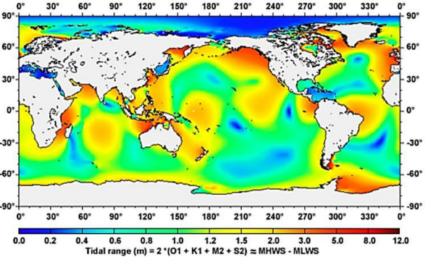
The magnitude of tidal currents depends on the local tidal range, water depth, and coastal geometry. In some nearshore areas the tidal current is modest, while in other locations it can become strong enough to be one of the governing loads on the protection layer. The local response is important because the astronomical tide alone does not determine the current strength; the hydrodynamic characteristics of the coastal setting also play a major role.

Astronomical tide
The astronomical tide is the predictable part of the tide caused by the gravitational effects of the Moon and the Sun. It is the main source of tidal water-level variation and therefore the main driver of tidal current in the nearshore. Because this forcing is periodic and well understood, astronomical tides can be predicted with good accuracy once a location has been analysed.

For this thesis, the astronomical tide is the primary reference because it determines the timing of high water, low water, flood, ebb, and slack water. These water-level changes directly control the direction and strength of tidal currents above the seabed. In other words, the current is not separate from the tide, but a direct consequence of the tide’s rise and fall.

The astronomical tide does not behave exactly like a simple sine wave in coastal waters. Its shape is modified by local hydrodynamics, water depth, friction, and coastal geometry. As a result, the local tidal signal may be amplified, delayed, or distorted. This means that even though the astronomical forcing is known, the resulting nearshore current conditions must still be evaluated locally. 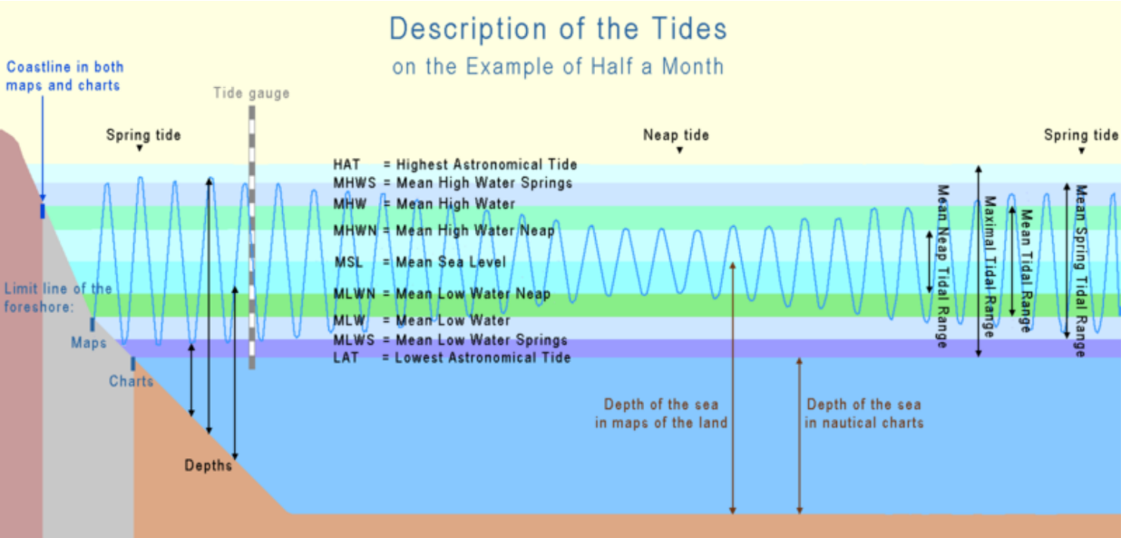

Tide types
The tidal pattern at a location can be semidiurnal, diurnal, or mixed. This distinction is important because it affects how often the current reverses and how the hydrodynamic load is distributed over time.
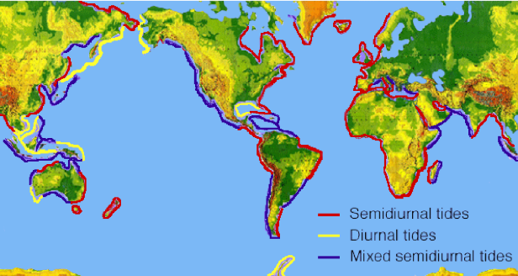
A semidiurnal tide has two high waters and two low waters per day. In this case, tidal currents typically reverse twice per day, which creates a regular and repeating loading pattern.
A diurnal tide has one high water and one low water per day. Here, the current reverses less frequently, but each current phase lasts longer.

A mixed tide lies between these two types and has two high waters and two low waters per day, but with unequal heights. In mixed tide conditions, one current direction may be stronger than the other, which can create an asymmetric scour pattern around the protection layer.

For nearshore protection design, the tide type is important because it controls the temporal pattern of loading. A protection layer exposed to semidiurnal tide experiences a different load cycle from one exposed to mixed or diurnal tide.

Wind-driven Currents
Wind-driven currents arise from the transfer of momentum from the wind to the sea surface. In the nearshore, they are usually less important than tidal currents, but they can still modify the local current field. They are especially relevant when wind acts in the same direction as the tidal current, because the two effects may reinforce each other.

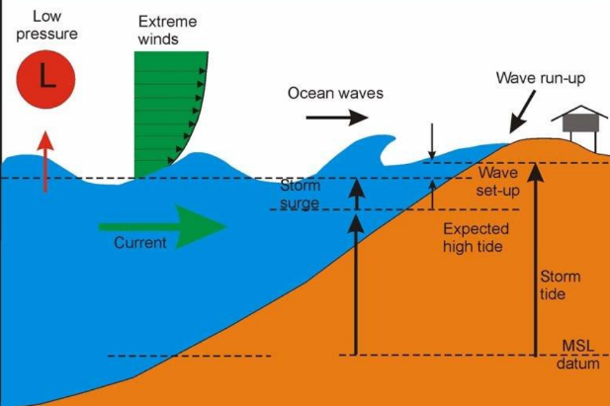
Wind blowing over the sea surface can also generate setup, which is a rise in water level near the coast. This can change the local pressure gradient and alter the current conditions in the nearshore zone. Although wind-driven currents are generally less predictable than astronomical tide, they should not be ignored if storm conditions are part of the design assessment.

For rock protection, wind-driven currents are mainly important as a secondary modifier of the total current field. Their direct near-bed contribution is often smaller than that of tidal currents, but they may still influence the combined loading during storm events.

Density-driven Currents
Density-driven currents are caused by horizontal differences in water density, usually related to salinity or temperature. In a standard open nearshore setting, this mechanism is often less important than tidal and wave-related flow processes. However, it can still be relevant in local areas where density differences exist.

In the nearshore zone, density-driven currents may contribute to a weak but persistent background flow. They can also influence the vertical structure of the water column and reduce mixing close to the bed. If present, this may affect sediment movement and the local turbulence conditions around the protection layer.

For this thesis, density-driven currents are therefore considered a secondary and site-dependent mechanism. They are not usually the governing load, but they may contribute to the total hydraulic environment if local conditions make them significant.

Wave-induces currents
Wave-induced currents are very relevant in the nearshore because wave motion affects the water movement close to the seabed. In the zone seaward of wave breaking, waves still produce oscillatory flow at the seabed, and this motion can interact with tidal flow. Even without breaking, wave orbital velocities can increase near-bed turbulence and contribute to the hydraulic loading on the protection layer.
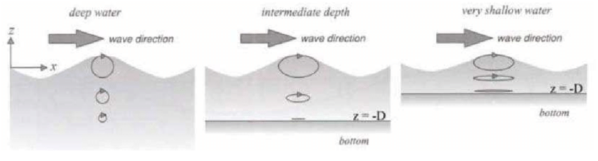
(Researchgate)

These wave-related currents are important because they do not act like steady currents. Instead, they produce repeated oscillatory motion that can destabilise stones, especially when combined with a background tidal current. In nearshore protection design, the combined effect of waves and tidal current is often more important than either process alone.

Current characterization for protection design
For protection design, currents should be characterized in a way that reflects their effect on the rock layer. The depth-averaged velocity is a useful first parameter, but it does not fully describe the loading condition. Near-bed velocity, flow direction, tide type, current reversal, turbulence intensity, and the combined action of waves and currents are all relevant.

In nearshore design, the most important practical question is not only how fast the current is, but how long it acts, how it varies through the water column, and whether it is combined with wave motion. A current of moderate average strength may still produce a critical load if it acts close to the seabed for a long period or if it coincides with energetic wave orbital motion.

For this reason, current characterization should always be linked to the local tidal regime and the local wave climate. A protection layer that is stable under current alone may still be vulnerable once wave-induced motion is added.

Waves
Waves are a major hydrodynamic loading mechanism in the nearshore because they generate oscillatory motion throughout the water column and, in particular, near the seabed. For the stability assessment of subsea cable protection, the relevant wave description must connect the available wave climate data to the local hydraulic loading at the protection location. In practice, this means that wave conditions are first obtained from measured data, hindcast data, or reanalysis products such as ERA datasets, after which they are translated to the site of interest using wave transformation methods.

The overall workflow in this thesis is therefore as follows. First, long-term wave conditions are characterised statistically using parameters such as $�_{�}$, $�_{�}$, and $�_{�-1,0}$. Second, these values are linked to the physical wave field through linear wave theory. Third, the wave conditions are propagated from the offshore or boundary location to the nearshore site of interest using either a numerical model such as SWAN or simplified transformation methods based on shoaling and refraction. Finally, the results are interpreted in terms of near-bed loading and possible wave breaking.

Source and description of wave data
Wave parameters used for design are typically derived from measured data, hindcast time series, or reanalysis products. Measured data provide direct observations at a specific location, but are often limited in duration. Hindcast datasets are generated using meteorological forcing and wave models and are useful for obtaining long time series. ERA-based reanalysis data can also be used as a source of wave climate information when a consistent long-term record is needed.

For this study, the important point is not only the data source, but also how the wave signal is interpreted and transformed. A long-term record can be used to derive representative and extreme wave conditions, which are then used as input for the stability assessment. In this way, the wave climate at offshore or regional scale can be translated into loading conditions at the actual cable protection location.

Statistical description of wave climate
Because sea states are irregular, wave conditions are usually described statistically rather than by a single deterministic wave. The sea surface can be regarded as a random process, and the wave climate is therefore represented using bulk wave parameters that capture the energy level and characteristic time scale of the sea state.

The most common wave parameter is the significant wave height $H_{s}$, which is defined as the mean wave height of the highest one-third of the waves:
$$H_{s}=H_{1/3}$$
This definition is widely used because wave heights in a random sea state are approximately Rayleigh distributed under linear wave theory assumptions. In other words, the upper part of the wave-height distribution contains the waves that contribute most strongly to the energy and to the loading of the sea state. For design purposes, $H_{s}$ is therefore a robust measure of overall wave severity.
A spectral alternative is:
$$H_{m0}=4\sqrt{m_{0}}$$
where $m_{0}$ is the zeroth spectral moment. For a narrow-banded wave field, $H_{m0}$ is approximately equal to $H_{s}$. This is useful because it allows wave height to be determined either from time-domain wave records or from a wave spectrum.

For long-term design, the statistical wave climate can be derived in different ways. Two common approaches are:
- the annual maxima method, in which the largest event in each year is analysed.
- the peak-over-threshold method, in which all independent wave events above a chosen threshold are used.

The annual maxima method is simple and widely used in extreme value analysis. The peak-over-threshold method makes more efficient use of the available data and is often preferable when a sufficiently long record is available. Both methods can be applied to measured, hindcast, or ERA-based wave series.

Wave periods and characteristic time scale
Besides wave height, the wave period is essential because it determines wavelength, wave speed, and the vertical extent of orbital motion near the seabed. The two most relevant periods in this thesis are the peak period $T_{p}$ and the spectral mean period $T_{m-1,0}$.

The peak period $T_{p}$ corresponds to the frequency at which the wave spectrum is maximal. It identifies the dominant energy-containing waves in the sea state and is therefore important for wave transformation and near-bed kinematics.

The mean spectral period $T_{m-1,0}$ is defined as:
$$T_{m-1,0}=\frac{m_{-1}}{m_{0}}$$
where $m_{-1}$ and $m_{0}$ are spectral moments. This parameter is useful because it represents the average energetic time scale of the wave field and is often more stable than the peak period when the spectrum is broad or irregular.

In practical terms, wave period matters because a longer period wave has a longer wavelength and a larger orbital reach. For the same wave height, this can change the amount of motion felt by the seabed and therefore the stability demand on the rock protection.

Linear wave theory
Once the statistical wave climate has been established, linear wave theory can be used to translate the offshore or boundary wave conditions into local wave kinematics. The theory assumes small wave steepness and provides a first-order description of the wave field that is suitable for engineering calculations.

The basic wave relations are:
$$ω =\frac{2π}{T}$$
$$k =\frac{2π}{L}$$
$$ω^{2}=gktanh⁡(kh)$$
where $ω$ is angular frequency, $k$ is wave number, $L$ is wavelength, $g$ is gravitational acceleration, and $h$ is water depth.

The wave celerity is:
$$c=\frac{L}{T}=\frac{ω }{k}$$
In deep water, wave speed is mainly controlled by the wave period. In shallow water, wave speed becomes increasingly dependent on depth and approaches:
$$c≈\sqrt{gh}$$
This change is important because waves slow down in shallower water, which is the physical basis for both shoaling and refraction. The group celerity, which governs energy transport, is given by:
$$c_{g}=nc$$
where $n$ is a depth-dependent factor. Since wave energy flux depends on $�_{�}$, the wave field changes as the waves propagate shoreward.

Wave propagation toward the site of interest
For this thesis, wave conditions at the location of interest are not assumed to be equal to offshore wave conditions. Instead, they must be propagated from the available wave data source to the site. This can be done with a numerical wave model such as SWAN, or with simpler engineering methods when the geometry and bathymetry allow it.

A model such as SWAN is useful because it can account for spatial variation in depth, wave direction, shoaling, refraction, bottom friction, and, where relevant, wave breaking. This makes it appropriate for propagating a wave climate over a realistic nearshore bathymetry to the point of interest.

In cases where a full model is not needed or not available, simpler propagation can be performed using shoaling and refraction relations. This is less detailed than a numerical model, but it still provides a physically meaningful estimate of how the wave climate changes between the offshore boundary and the nearshore protection location.

Shoaling is the increase in wave height as water depth decreases. It occurs because the group velocity decreases in shallow water while the energy flux must remain approximately conserved. A simple expression for the shoaling coefficient is:
$$K_{s}=\sqrt{\frac{c_{g0}}{c_{g}}}$$
where $c_{g0}$ is the deep-water group velocity and $c_{g}$ is the local group velocity.
The local wave height can then be written as:
$$H=K_{s}H_{0}$$
where $H_{0}$ is the offshore wave height.
Shoaling is important for stability because it means that the wave height at the nearshore protection layer can be larger than the offshore wave height. This increase in wave height leads directly to stronger near-bed orbital motion and a higher hydraulic load on the rock layer.

In addition to shoaling, waves undergo refraction when they approach the coast at an angle and the bathymetry varies laterally. Refraction occurs because the part of the wave crest that enters shallower water first slows down earlier, causing the crest to rotate toward the depth contours.
$$K_{r}=\sqrt{\frac{\cos_{θ0} }{\cos_{θ1}}}$$
$$H=K_{s}K_{r}H_{0}$$

Wave direction is therefore a relevant design parameter. It affects not only the local transformation of wave energy, but also the direction of the resulting near-bed flow. This is important because the interaction between waves and currents depends on their relative angle, and because oblique wave approach may create local energy concentration or dispersion along the cable route.

For this reason, the wave climate should not be described only by wave height and period. The incident wave direction must also be included, especially when the nearshore bathymetry is variable or when the route is exposed to oblique wave attack.
Wave breaking occurs when the wave becomes too steep or when the local water depth becomes too small for the wave to remain stable. A common depth-limited form is:
$$H_{b}≈γh_{b}$$
where $H_{b}$ is the breaking wave height, $h_{c}$ is the breaking depth, and γ is the breaker index.

Breaking is important because it marks a qualitative transition in loading. Before breaking, the wave field is mainly oscillatory and can be described reasonably well by linear wave theory and standard transformation methods. After breaking, the flow becomes turbulent and impulsive, and the loading on the seabed changes fundamentally.

This is why breaking waves must be treated as a separate loading category. A protection layer that is stable under non-breaking wave motion may not remain stable once breaking occurs, because the forcing mechanism is no longer smooth oscillatory motion but turbulent energy dissipation and impact loading.

Relevance for stability
For the stability assessment of rock protection along subsea cables, the relevant wave process is the propagation of the long-term wave climate to the nearshore location and the translation of that climate into local hydraulic loading. The most important parameters are $H_{s}$, $T_{p}$, $T_{m-1,0}$, and wave direction, together with local depth and bathymetry.

The practical sequence is:
- obtain measured, hindcast, or ERA-based wave data;
- determine representative and extreme values of $H_{s}$, $T_{p}$, $T_{m-1,0}$ ;
- use linear wave theory to derive wave celerity, group celerity, and wavelength;
- propagate the wave signal to the site of interest using SWAN or simplified shoaling and refraction calculations;
- check whether the waves remain non-breaking or enter the breaking regime.

This sequence is important because stability depends on the actual local wave load, not on the offshore wave climate alone. Breaking waves are therefore handled separately from non-breaking waves, since they belong to a different hydraulic regime with different implications for the design of nearshore rock protection.

- Lecture Notes Harbour Engineering

Wave-Current interaction
Critical section for nearshore: in practice, waves and currents always act simultaneously, and their interaction produces higher bed-shear stresses than either alone.

- Physics of this interaction
- complication of stability assessment.

- Schiereck & Verhagen (2019) —
Ch. 7 (Waves: loads, linear wave theory, wave statistics, wave generation, breaking waves)
Ch. 2 (Flow loads)
- Van Rijn (2019)
Section 2 (Critical bed-shear stress, combined current and wave conditions, Eq. 5)
- Deltares Handbook (2023)
Ch. 2 (Scour prediction, general description of the scour process)

Near-bed Flow Conditions
What happens at the bed level, because that is what the stones of your protection actually experience.

Boundary layer theory
Velocity profiles above a rough bed
Distinction between uniform and non-uniform flow.

Turbulence as a phenomenon: what it is, how it develops in nearshore environments (waves, bed roughness, structures)

Why elevated turbulence makes standard stability criteria less reliable. Reference Hofland (2005) as the key source for the turbulence problem

(cited directly by Van Rijn (2019) in your literature)

- Schiereck & Verhagen (2019)
Ch. 2.2 (Turbulence)
Ch. 2.3 (Wall flow, uniform flow, non-uniform flow)
Ch. 3.4 (Non-uniform flow)

- Van Rijn (2019)
Section 1 (Introduction, reference to Hofland 2005 on turbulent kinetic energy)

- Deltares Handbook (2023)
Ch. 4.2.1 (External stability of loose rock scour protections)

Stability Parameters & Criteria

The Shields Parameter — Uniform Flow
Shields curve and the critical Shields parameter as the classical stability criterion for uniform flow.

Validity, the scatter in the data, and the practical application via the reduction factor r (Van Rijn, 2019).

Which situations Shields is reliable? And where not?

Turbulence-based Parameters
Extension of Shields towards situations with elevated turbulence (Hofland (2005))

Turbulent kinetic energy (TKE), additional stability parameter alongside mean velocity. When is this approach becomes necessary?

Combined Wave-Current Conditions
Bed-shear stress is computed under combined wave and current conditions, in particular the approach of Van Rijn (2019) where τb,cw = τb,c + τb,w.

Friction factors fc and fw and the simplified power functions introduced for practical use.

Decision Framework
A clear table or decision tree: under which hydrodynamic conditions which parameter? Uniform current → Shields.
Non-uniform or high turbulence → TKE approach.
Wave-dominated → Van der Meer.
Combined → Van Rijn.

Really important also for the Code!

- Schiereck & Verhagen (2019)
Ch. 3.2 (Uniform flow, horizontal bed, basic equations, threshold of motion, stone dimensions)
Ch. 8.3 (Stability of loose grains, bed stability under wave loading)

- Van Rijn (2019)
Section 2 (Critical Shields mobility parameter, Eq. 1–5, reduction coefficient r, Table 1)

- Deltares Handbook (2023)
Ch. 4.4.1 (External stability, deformation model, mobility limits)

Rock Stability Assessment Methods
The core of comparative analysis. For each method

- the physical assumptions
- the input parameters
- the output quantity
- the damage level it is calibrated against
- the validity limits.

Comparison of these points.

Hudson Formula
Classical method, primarily for wave loading on slopes. Simple but with strong limitations: no wave period, no current, empirically calibrated on a limited dataset. Still widely used as a first estimate.

Van der Meer (1988/1998)
Extension of Hudson, introduces wave period and permeability. Widely applied but developed for breakwater armour, not specifically for cable berms.

Van Rijn (2019)
Extended Shields approach for large stones under current and/or waves. Introduces damage classes via reduction factor r. Validated with field and laboratory data for materials ranging from 0.03–3 m. Most relevant for dynamic protection design.

Van Gent & Van der Werf (2014)
Stability formula for toe structures based on characteristic orbital velocity û. Explicitly includes berm geometry (Bt, tt) in the formula. Uses NOD as the damage function. Valid for slopes 1:1.5 and 1:2. Includes roughness correction factor for smooth armour slopes.

Herrera & Medina (2015)
Specifically developed for very shallow water (hs/Hs0 < 1.5) and steep sea bottoms (m = 1/10). Demonstrates that existing formulae fail under these conditions. Directly relevant for nearshore cable routes on steep coastal profiles.

Deltares HaSPro Handbook (2023)
State-of-the-art for offshore cable and foundation protection. Treats external stability, interface stability, and flexibility as three separate performance requirements. Introduces the rock berm deformation model for cable crossings. Most directly applicable design reference for your framework.

Comparative Summary
Method | Situation it was made for | Required inputs | Output | Damage criterion | Validity limits | Fit for nearshore cable berm
Hudson (1958) | Slope armour, rubble-mound, non/mild breaking | Hs, KD, Δ, cotα | W50 / Dn50 | Implicit fixed (~0–5%), no scale | Slope armour; no Tp, no current; small dataset | Low – first estimate only
Van der Meer (1988/98) | Slope armour, random waves | Hs, Tm (sm), Δ, Dn50, cotα, permeability P, N waves, Sd | Dn50 / Ns at given Sd | Sd = Ae/Dn50² (start ≈2, failure ≈8–17) | Slope armour, not depth-limited; no current | Low–med – slope, not berm/bed
Van Rijn (2019) | Horizontal/mild-slope bed protection, current ± waves | uc, Hs, Tp, h, Δ, slope, α(ks), r, γstr | required D50; + Nmr/Sd (Cheng) | r = 0.4–1.0 → θcr = r·0.05; Sd / moving rocks | D50 = 0.03–3 m; horizontal/mild slope; sparse field calibration | High – only one with combined wave+current; static & dynamic
Van Gent & Van der Werf (2014) | Toe of breakwater armour slope | Hs, Tm-1,0, ht, Bt, tt, Dn50, Δ, cotα, roughness | Nod or Dn50 | Nod (displaced stones / Dn50 width) | ht/h = 0.10–0.30; h/Hs = 1.2–4.5; slopes 1:1.5 & 1:2; waves only | Med – berm geometry fits, but assumes armour slope above & down-rush
Herrera & Medina (2015) | Toe berm, very shallow + steep (m=1/10), breaking | hs, Hs0, L0p (Tp), Δ, Dn50 (std Bt=3Dn50, tt=2Dn50) | Nod (Eq. 12) + 90% CI | Nod (0.5 start, 1 design, 2 moderate, 4 failure) | −0.15<hs/Hs0<1.5; −0.5<hs/Dn50<5.01; 0.02<s0p<0.07; m=1/10; std berm only | Med–high for bedrock/steep breaking; fixed geometry, waves only
Deltares HaSPro / RoBeD (2023) | Loose-rock scour protection & cable-cover berms, offshore, current+waves | Shields θ (→ uc, Hs, Tp, h, Δ, D50), WTOP, MTOC, Dcable, side slope | berm geometry (Bberm/hberm, TOPC) + deformation class; external/interface/flexibility | mobility threshold ≈0.95; classes 0–3; reshaping θ>~0.06 | reshaping regime; perpendicular wave+current assumed; offshore-calibrated | High – only one explicitly for cable berms + 3 requirements

Situation | Primary method | Supporting / check | Why
Bedrock, steep nearshore, breaking waves | Herrera & Medina (2015) | Van Gent (range check); Hudson (first estimate) | Only method for steep bottom + breaking; demonstrates that gentle-slope formulas fail here.
Mobile sand, combined waves + current (crossing/obstacle) | Van Rijn (2019) | Deltares RoBeD (deformation + interface/flexibility) | Only method with genuine wave+current on a bed; Deltares covers winnowing/falling apron on sand.
Cable berm geometry & reshaping/deformation (any) | Deltares RoBeD (2023) | Van Rijn (D50 sizing) | Provides berm geometry + deformation class rather than only D50.
Quick first sizing / sanity check | Hudson / Van der Meer | — | Classical and fast, but without wave period or current.

- Schiereck & Verhagen (2019)
Ch. 8.2 (Stability general)
Ch. 8.3 (Stability of loose grains, slope stability under wave loading)

- Van Rijn (2019) — full paper

- Van Gent & Van der Werf (2014/ICCE2014) — full paper

- Herrera & Medina (2015) — full paper

- Deltares Handbook (2023)
Ch. 4 (Design of loose rock scour protections)
Ch. 5 (Loose rock berms at cable crossings)

Scour

The Scour Process
Scour as an erosion phenomenon,
- global scour (general bed level lowering due to morphodynamics)
- local scour (around a structure).

Clearwater vs. live bed scour: mechanism, equilibrium depth, and hysteresis over a flood hydrograph.

Scour Around Subsea Cables
Cables are elongated, relatively narrow objects lying on or near the seabed. This is physically fundamentally different from scour around a monopile or breakwater!

Discussion how flow and waves behave around a cable, when a cable becomes free-spanning, and what the consequences are for structural integrity?

The Scour Process
Scour beneath or alongside a protection berm undermines its stability, the berm loses its foundation support.

How scour and berm stability are coupled and why they cannot be designed independently?

The Scour Process
Overview of solutions: loose rock protection, rock berms, and alternative systems (mattresses, artificial vegetation, gabions) as described in the Deltares Handbook. Indicate which approach is suitable under which conditions.

- Schiereck & Verhagen (2019)
Ch. 4 (Flow-Erosion: scour as sediment transport, scour process, scour with bed protection, equilibrium scour, stability of protection)

- Deltares Handbook (2023)
Ch. 2 (Scour prediction)
Ch. 3 (Scour mitigation strategies A/B/C)
Ch. 5 (Loose rock berms at cable crossings)
Ch. 9–11 (Alternative systems)

Design Framework & Computational Approach

Input Parameter Space
All parameters required for a stability assessment, grouped by category: hydrodynamic (Hs, Tp, Tm-1,0, uc, wave direction), geometric (h, ht, bed slope), material (Dn50, ρs, D50) and berm geometry (Bt, tt). For each parameter, physical meaning, unit, and typical nearshore range.

Core Design Formulae
All formulae that will be implemented in the Python script, written out in full with variable definitions.

This chapter is the technical foundation of the script, every formula here maps directly onto the code.

Organization per method so its well-structured for the code. Like Chapter 6?.

Failure Criteria & Damage Levels
Stability for each method.

Shields with a threshold (θ ≤ θcr).
Van Rijn with damage classes (r = 0.4 to 1.0).
Van Gent NOD with an acceptable upper bound.

I have to make these differences explicit so they can be implemented consistently in the script.

Validity Ranges & Applicability Warnings
State the validity limits per method (e.g. Van Gent: ht/h = 0.10–0.30, h/Hs = 1.2–4.5). In the script these become the warnings issued to the user when input falls outside the valid range. This is essential for a tool intended for global application.

Sensitivity Analysis Framework
Sensitivity analysis as a methodology: Identifying which input parameters most strongly influence the outcome.

Which methods do I want to apply

local sensitivity analysis and global methods such as Sobol indices and the Morris screening method.

Thesis methodology chapter.

- Schiereck & Verhagen (2019)
Ch. 3.2 (Stone dimensions, waterdepth, practical application)
Ch. 10 (Dimensions, probabilistics, failure mechanisms)

- Van Rijn (2019)
Section 2–4 (all core formulae and validity ranges)

- Van Gent & Van der Werf (ICCE2014)
Equations 1–3 and validity discussion

- Herrera & Medina (2015)
Equations 1–4 and validity ranges

- Deltares Handbook (2023)
Ch. 4.4 (Design approach, external stability, interface stability, flexibility)
Ch. 4.5 (Design workflow, design parameters)

Knowledge Gaps & Research Questions
Conclusion of theliterature review.

What do I know:
- stability criteria for uniform flow are well developed,
- the Deltares HaSPro approach is state-of-the-art for offshore applications,
- and several methods exist for toe and berm stability.

What we do not know:
- there is no validated, integrated method specifically for nearshore cable berms under combined wave-current conditions,
- and existing methods are frequently applied outside their validity ranges without adequate justification.

I have to formulate the research questions that follow directly from the literature, which justify my methodology chapter and the development of my Python tool.

https://www.researchgate.net/publication/235634121_Experimental_Investigation_of_Water_Wave_Characteristics_in_a_Wave_Channel/figures?lo=1

